**Peony Bouquet**

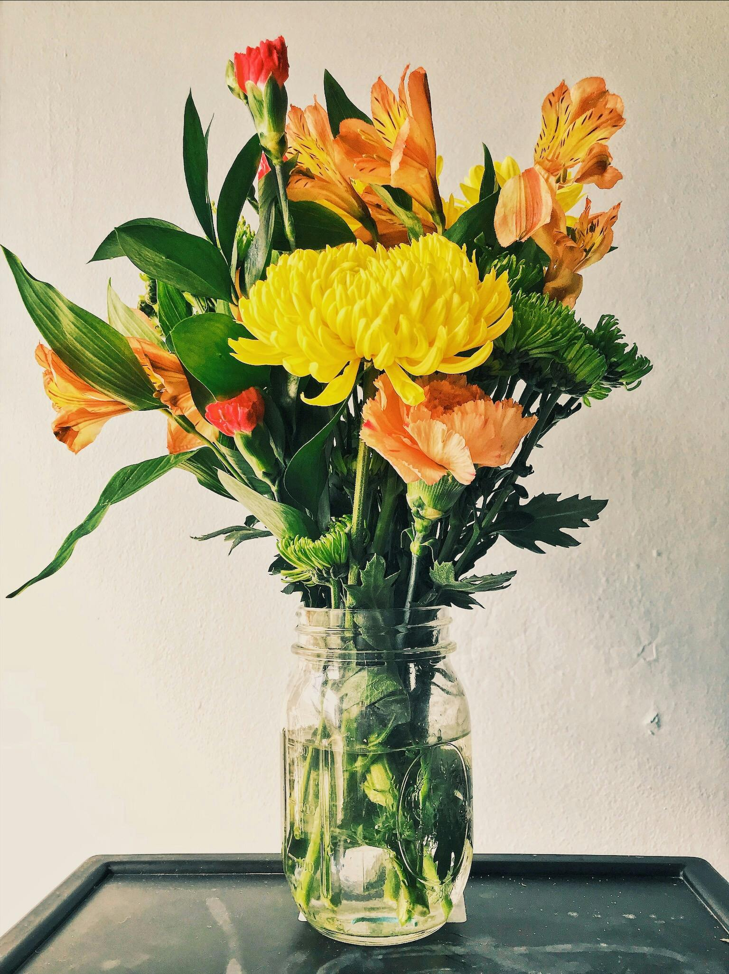

A peony bouquet is a delightful arrangement of freshly cut peony flowers, known for their lush, fragrant blooms and vibrant colors. Typically handcrafted by skilled florists, these bouquets offer elegance and charm, perfect for various occasions such as weddings, anniversaries, or simply as a thoughtful gift. Peonies symbolize romance, prosperity, and good fortune, making them a popular choice to convey heartfelt sentiments. Whether in soft pastel hues or bold, vivid tones, a peony bouquet adds a touch of beauty and sophistication to any space or event.

**CATEGORIES:** Classic Peony Bouquets,Romantic Peony Arrangements,Vintage Peony Bouquets,Rustic Peony Bouquets..

**INFORMATION**: Peonies have many meanings depending on their colour. Overall, the flower is considered to symbolise bashfulness or good luck, while in China and Japan the blooms mean wealth, honour and fortune. Peony flowers are also said to represent compassion, making them a strong choice for many looking for sympathy bouquets.

**Price**: ~~$39.00~~ $29.00